Best Friends Animal Rescue
1380 Buena Vista Rd
Russellville, KY 42276
270-772-2919

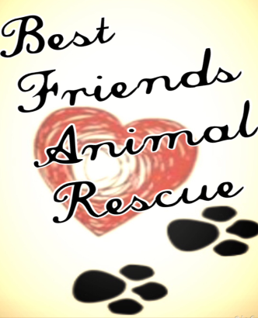

SPAY/NEUTER AGREEMENT
ADDENDUM TO ADOPTION CONTRACT

For_______________________________

It is strictly against Best Friends Animal Rescue policy to let a dog leave our care without first being spayed or neutered. The only exception to the policy is in the case of puppies which are too young to undergo surgery before they are adopted. In that case, this Spay/Neuter Agreement is incorporated by this reference into our standard Adoption Contract. Permanent adoption of this dog is contingent upon your compliance with this agreement. Proof of spay/neuter must be received by Best Friends Animal Rescue within fourteen (14) days after the surgery.
In the event that the dog’s health does not allow this agreement to be honored
by the agreed - upon date, Best Friends Animal Rescue must be provided with a
written statement from your veterinarian that this dog is not yet in physical or emotional condition for surgery.
The spay/neuter deadline date specified below will be amended to the date your veterinarian deems appropriate and safe. All other terms and conditions
of the Adoption Contract and this Addendum will remain in full force and effect.
It is the responsibility of Adopter, not the veterinarian, to ensure that
Best Friends Animal Rescue has received verification that the surgery has been performed. Failure to comply with this agreement by the date below, unless otherwise agreed to in writing, will be considered a breach of the Adoption
Contract, and Adopter agrees to transport this dog back to Best Friends Animal Rescue within five (5) days. It is understood and agreed that Adopter will not be entitled to a refund of the adoption fee.
By my signature below, I agree to have this dog spayed/neutered by no later than
__________________________.
I understand that this spay/neuter agreement is a commitment that this dog will not produce a litter of puppies, either as purposely bred or by accidental breeding. I also agree that should puppy not be altered I will return puppy as agreed above and without refund of my adoption fee.

Signature: ___________________________________

Date: ____________________, 20______

Name:
(please print) _______________________________________________

Address: __________________________________________________

City, State, Zip Code__________________________________________

Telephone (including area code):_________________________________

